Use Genetic Algorithm to solve TSP

- Method and step introduction
Genetic algorithm is base on biological theory.

(Key word: genotype, phenotype, evolution, fitness, selection, reproduction,
Crossover, mutation, coding, decoding, individual, population.)

We mainly use GA to solve TSP problem, first we have a population of feasible solution, then we use fitness function to pick out the parental population, then we use crossover and mutation technology to generate a child population, then we replace it with the original population.
Then repeat all the processes above.
One sentence to introduce: we constantly map a population to certain better population using a fitness degree.

Pseudo code:
Populaition P;
SolutionSet S;
newPopulation N = empty;
P=S;

string globalMin;

while (!terminate())
{
for x $∈ p$
if x.fitness>standard
N = N$∩$x

crossover(N)
mutation(N)

for each v $∈$ N
if(v.fitness>globalMin.fitness)
globalMin=v

P = N;
}

Now, specific steps:

- Choose a population pool
- Test stop condition (some solutions appears for constant times)
- Evaluate the fitness value of each solution.
- Rank the fitness value from high to low, if high, then the possibility of selection is also high.
- Select highest 20 solutions as Elitism, and directly add those elites to the next generation, rest of the population we randomly select father and mother, then we reproduce offspring---crossover father and mother’s chromosome, and generate child.
- Mutate child’s chromosome.
- We select all the child and first 20 elites as the new generation.
- Return to step2, is fulfilled, exit the program.

At last, in the process of cross over and mutation, the relationship between phenotype and genotype need to be build (e.g. phenotype is the city string, and genotype is your binary code after encoding).

- Method flow chart
Activity diagram
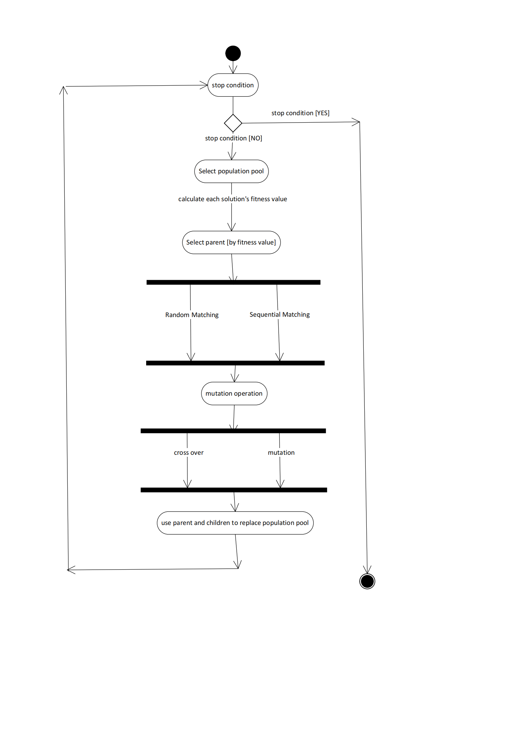

- Design details
In this algorithm, we mainly use 100 initial solutions to generate result, and get the average best result. Also we apply different neighborhood structure to the Genetic Algorithm’s mutation part, we will talk about it later. Final, we will derive the result about the GA’ s quality of solution and solution’s stability.

- Fitness Function:
Fitness()
{
For i=1 to pop.size
For j=1 to chromosome.size-1
Distance=Distance+cost<${gene}_{j},{gene}_{j+1}>$
Pop[i].value=Distance
Distance=0

For i=1 to pop.size
Pop[i].fitness=pop[i].#city/pop[i].value
}

You can see that, we use the $\frac{city number}{distance}$ as the fitness value.

- Parent selection
- Roulette Wheel
Solution x, y, z, first, use fitness function to get, f(x), f(y), f(z), then, use
- Elitism
- Stochastic Universal Sampling

In the select parent part, we select best 20 elite with highest fitness value. For the rest of the population, we will make them reproduce children by randomly mating, this means for every solution left, just mate with other solutions for random times. Then, we will collect all the offspring, and add all the elite to compose a new generation.

- Encoding:
- Binary coding
- Floating point coding
- Neither of them, we just use the city string as the code to do the cross over

- Cross over:
only exchange the red part, but the red part’s size and position can be random

A B C D E F

B C A E F D

- Mutation.
Each allele on a chromosome (child) has a mutation factor, we call it <p>, after parents reproduce the child, we check each alleles, and generate a mutation factor <p1> sequentially, once <p1> greater than <p>, the allele will mutate and exchange with another random allele.

- New Population Pool.
We use the 20 elite and the children to replace the original population pool.

- Experimental procedure
- Development environment: Microsoft Visual Studio 2019
- Operating system: Windows10
- Configuration of the Computer:
CPU: AMD Ryzen5 3500U 2.10GHz
RAM: 16GB

5. Assessment:
A. Quality of obtained solutions

(figure 1)

(figure 2)

Figure 1 shows that, we implement GA on 100 initial solutions and get their final optimal solutions, however, we think that, different mutation structure may influence the mutation, so we use 5 different neighborhood structures to conduct the mutation. If you remember, our original mutation is to swap the allele with a random allele, now, we just use neighborhood structure on the entire city string. For example, A-B-D-F-E-G-H, after implement 3-OPT, we let i=E, j=A, we choose B, G to swap, we get A-G-D-F-E-B-H.
From the figure 2, we can say that, for the quality of the solution of GA, 2OPT>1OPT>3OPT>City Insertion>Random exchange Mutation (> means quality is better). from the figure 1, we can also tell that the all the 5 neighborhood structures applied in mutation can bring us the optimal solution.

- Convergence time

(figure 3)

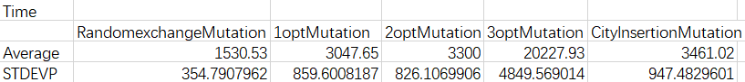
(figure 4)

From figure 3 and 4, it shows that converge time of GA applying 5 neighborhood structures has the following order:
Random exchange<1OPT<2OPT<City Insertion<3OPT, it means that GA with random exchange mutation will converge in the fastest way.

- Stability
(figure 5)

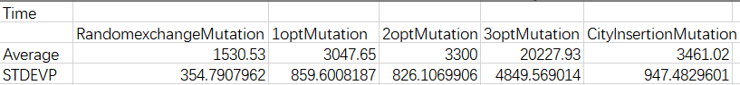
(figure 6)

The stability of GA’ s solution and convergent time will both be evaluated by the standard deviation. From figure 5’s standard deviation, we can deduce that 2OPT>3OPT>1OPT>random exchange>city insertion, here, “>” means stability is better since variation is small. Also, we can also tell the original solution is much more unstable compared to other structures.
From figure 6’s std, it is clear that random exchange>2OPT>1OPT>City Insertion>3OPT. Do the random exchange method has the best time stability.

6. Discussion and Conclusion
Quality of the solution: 2OPT>1OPT>3OPT>City Insertion>Random exchange
Convergence Time: Random exchange<1OPT<2OPT<City Insertion<3OPT

Stability:
- Quality of solution: 2OPT>3OPT>1OPT>random exchange>city insertion
- Convergence Time: random exchange>2OPT>1OPT>City Insertion>3OPT

